Key management Problems Solved
- Where are my keys?
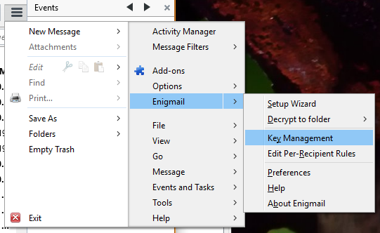
Remember: Enigmail always uploads the PGP-keys (public certificates) to the default keyserver.
- How to know what is my default server?
- Go to Enigmail->preferences
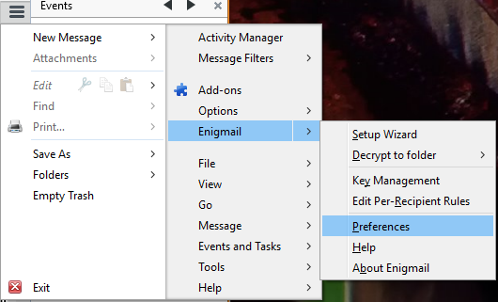
- In the Enigmail Preferences window click on [Display Expert Settings and Menus] to get the Expert menu.
- Now click on Keyserver tab.
- The first server listed in the Specify your keyservdr(s) is your default keyserver.
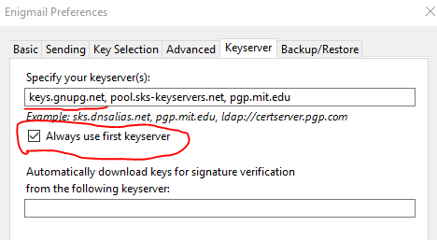

- How to search for uploaded keys?
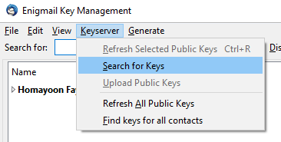

- How to upload your key to a keyserver?
- While In the Enigmail Key Management window, right click on your key and choose “Upload Public Key to Keyserver”
Note: If you upload to mailvelopvelop keyserver then remember that mailvelop vil send you a verification emai. You must verify it.
- If upload fails
- If upload fails, then try to download the newest version of GnuPGP and install it.
- If it still fails to upload then right click on your key and choose “copy public keys to clipboard”.
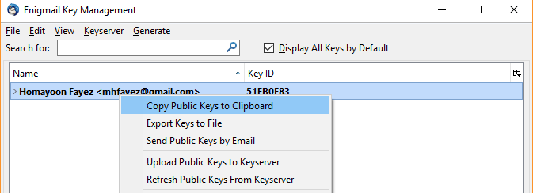
- Brows to one of the keyservers e.g http://keys.gnupg.net/
- click on Submit Key button
- paste the key inside the box by pressing Ctrl + V
- click on Submit Public key button

